

**Batch: B–1 Roll No: 16010422234 Experiment No: 6**

**_____________________________________________________________________________**

**Aim: N**odejs application deployment using Kubernetes (PaaS)

**_____________________________________________________________________________**

**Resources needed:** killercoda (online playground)

**_____________________________________________________________________________**

**Theory:**

Kubernetes is a portable, extensible, open source platform for managing containerized workloads and services that facilitates both declarative configuration and automation. It has a large, rapidly growing ecosystem. Kubernetes services support and tools are widely available.

**_____________________________________________________________________________**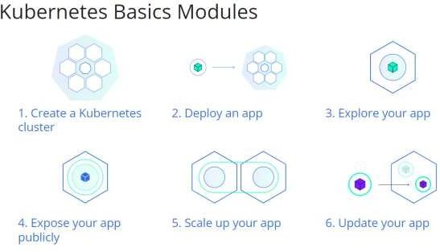

**Procedure:**

1. Explore all 1 to 4 modules.
2. 10 kubctl commands on killercoda (online playground).
3. Deploy an app on killercoda (online playground).
4. Explore and Expose an app (preferably image created in docker experiment).

**_____________________________________________________________________________**

**Results: (Result of Steps with screenshots)**

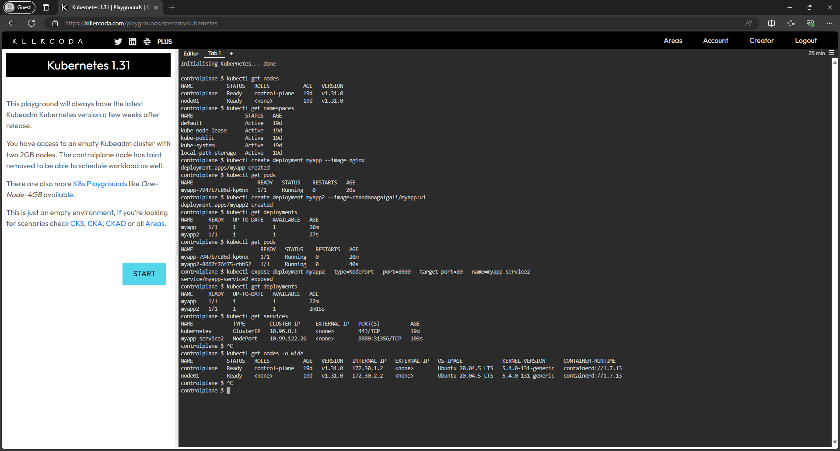

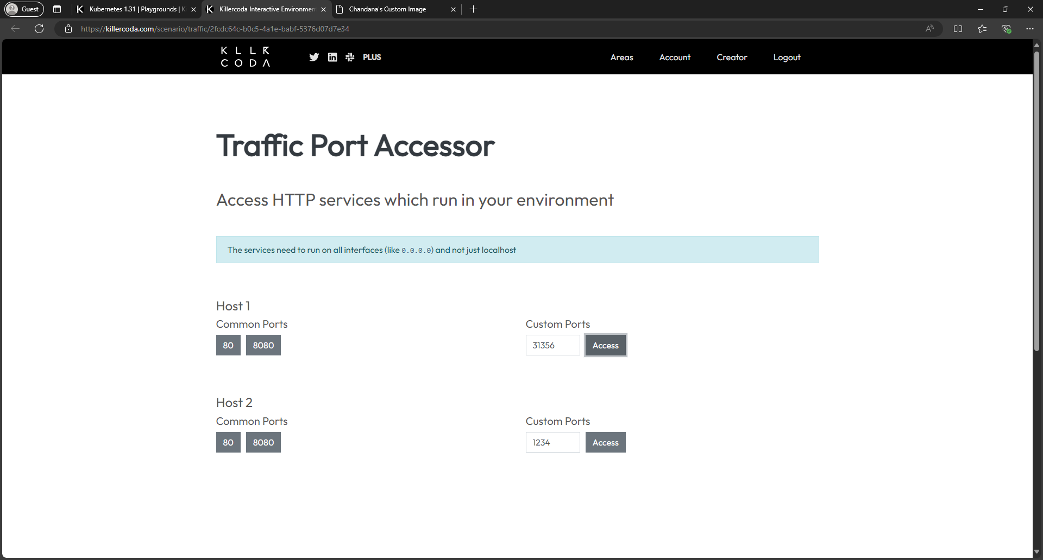

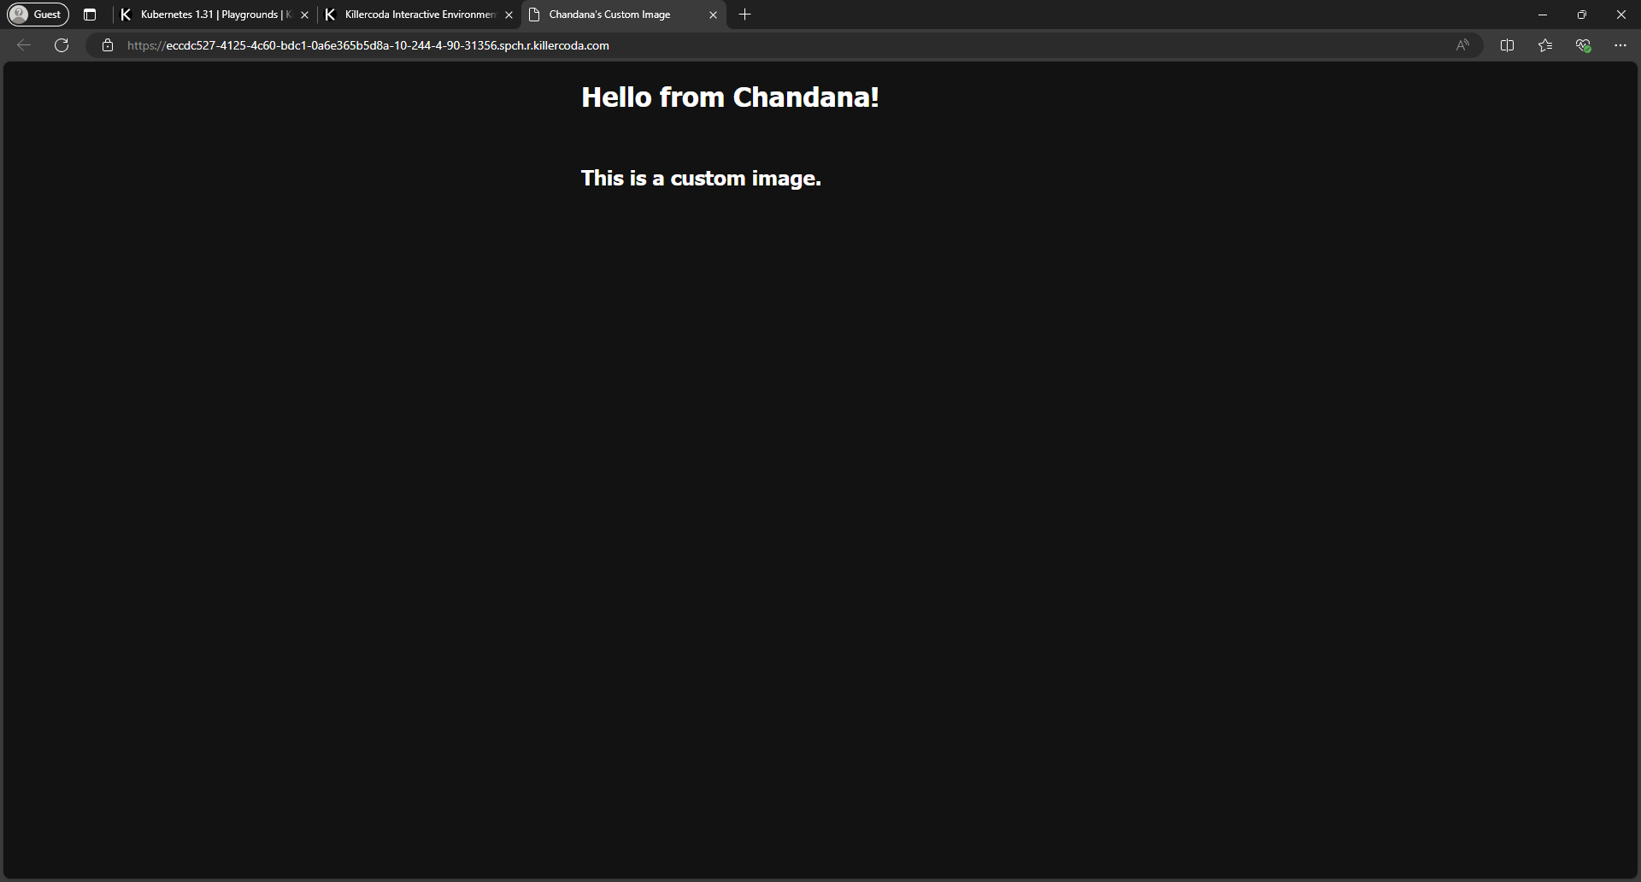

**_____________________________________________________________________________**

**Questions:**

**Q1. Explain micro-services with an example.**

**Ans:** Microservices, also known as the microservices architecture, is a design style where an application is built as a collection of small, autonomous services modeled around a specific business domain. Each service is independently deployable, scalable, and loosely coupled with others. This approach allows teams to develop, test, and deploy features faster and more effectively.

Example:

An e-commerce application can be divided into several microservices:

* User Service: Manages user registration, authentication, and profiles.
* Product Service: Handles product catalog, details, and inventory.
* Order Service: Manages cart operations, order placements, and payment processing.
* Shipping Service: Manages shipment tracking and delivery status.

These services communicate with each other via lightweight APIs (e.g., REST or gRPC) while remaining independent in functionality and deployment.

**_____________________________________________________________________________**

**Outcomes: CO3 – Analyze different cloud architectures and IoT-cloud.**

**_____________________________________________________________________________**

**Conclusion: (Conclusion to be based on the objectives and outcomes achieved)**

The experiment demonstrated the deployment and management of a Node.js application using Kubernetes on Killercoda, showcasing key features like container orchestration, declarative configuration, and service exposure, emphasizing Kubernetes as a powerful tool for modern PaaS solutions.

**_____________________________________________________________________________**

**Grade: AA / AB / BB / BC / CC / CD / DD**

**Signature of faculty in-charge with date**

**_____________________________________________________________________________**

**References:**

**Websites:**

1. <https://kubernetes.io/docs/tutorials/kubernetes-basics/>
2. <https://killercoda.com/playgrounds/scenario/kubernetes>
3. 5 steps to Deploy docker image to Kubernetes
4. <https://www.youtube.com/watch?v=95zmJnz4iOo>

**_____________________________________________________________________________**